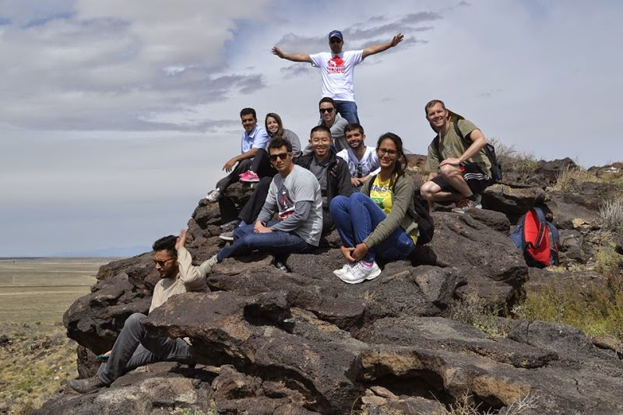

**Become a CELAC Ambassador!**

**CELAC Mission Statement**

The mission of the Center for English Language and American Culture (CELAC) is to provide the highest quality academic English language training for international students seeking admission to the University of New Mexico and other U.S. institutions of higher education. In carrying out its mission, CELAC contributes to the internationalization of UNM by increasing the number of international students on campus, and by providing language proficiency testing and individualized admissions assistance and counseling for both international and resident, non-U.S. citizen students. Further, CELAC serves UNM and the community of the state of New Mexico as a research site for second language acquisition study, and as a site for ESL classroom observation.

**Contact Linka Crosby at** [**celacvolunteerprogram@gmail.com**](mailto:celacvolunteerprogram@gmail.com) **for further information about becoming a CELAC Ambassador.**

**Start Volunteering Today!**

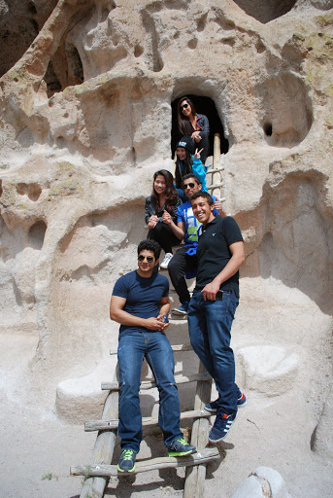



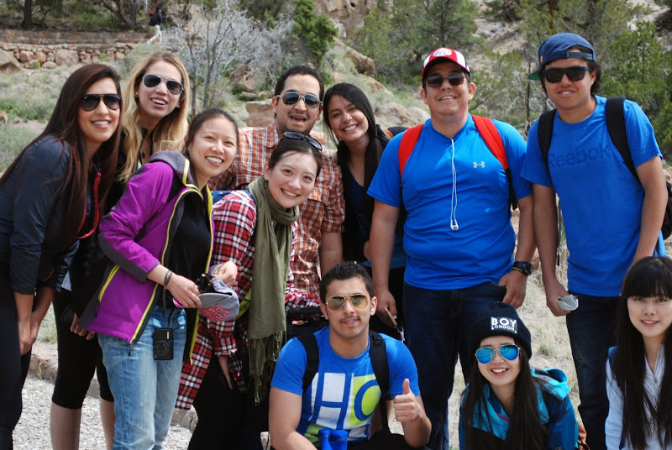





**CELAC Ambassador Program**

The CELAC Ambassador Program is organized to help international students adjust to cultural and academic differences with the help of the New Mexican community. This relationship allows international students and domestic students to engage in educational opportunities outside of the classroom as well as develop a foundation for effective, intercultural communication.

Another goal of the program is to promote internationalization of the UNM campus and of the New Mexican community. CELAC Ambassadors will meet with international students for social and conversational purposes in an informal setting. The program is meant to help our international students improve their English skills and learn more about U.S. culture and introduce our local students to the cultural diversity of our campus and the world

**Opportunities for CELAC Ambassadors**

* Meet once a week for conversation
* Spend quality time attending sports games, CELAC student events, club events, community programs, library programs, etc.
* Visit museums and historic sites in the area to learn about some aspects of American culture
* Join hiking and camping trips
* Assist with airport pickup
* Housing assistance
* Help with shopping and getting familiarized with local stores
* Tutoring

Adapted from: Black Hawk College Peer Mentor Program

Adapted from Black Hawk College Peer Mentor Program

**CELAC**

The Center for English Language and American Culture (CELAC) is an intensive English language program for international students learning English and American Culture.



**CELAC Ambassadors**

The Center for English Language and American Culture (CELAC) is seeking kind, friendly, and culturally sensitive volunteers who are interested in helping with tutoring, being a conversation partner, or showing our students the beautiful sites of New Mexico. Our students come from all over the world and are interested in learning about American culture.

If you are interested in becoming a CELAC Ambassador, please contact **Linka Crosby at celacvolunteerprogram@gmail.com.** Please attach a cover letter, resume, and one reference to this email. We look forward to hearing from you.

**GOALS and OBJECTIVES**

* Facilitate international students’ academic and cultural transitions
* Help students with English communication
* Encourage students with participation in non-education and social opportunities, such as student organizations and community events
* Assist students in developing relationships with the University of New Mexico, their peers, and the community