Data are prepared from N=25 Parkinson’s patients ON and OFF medications (1 week apart) and N=25 matched controls.
The task was an auditory oddball task consisting of:
- Standards (440 Hz sinusoidal tone for 200 ms) – 70% of trials
- Targets (660 Hz sinusoidal tones for 200 ms) – 15% of trials
- Novel Distractors (unique 200 ms snippets from a sound library) – 15% of trials
There were two blocks of 100 trials each. Thus, there were 140 Standards, 30 Targets, and 30 Novel trials per subject. There was a random inter-trial-interval selected from a uniform distribution of 500 to 1000 ms. Participants were instructed to count the Targets and ignore Standards and Novels. This is a common procedure to simply verify that they were paying attention.
EEG data were pre-processed, and some trials were removed due to artifacts. Eye blink activities were identified via Independent Component Analysis (ICA); these contaminated components are removed immediately after uploading the data (in the script below). EEG data are average referenced, 500 Hz, with 60 channels (see BV_Chanlocs_60mat for locations). Events are indicated by unique triggers sent from the stimulus presentation program (Matlab Psychtoolbox):
- Standard = 201
- Target = 200
- Novel = 202

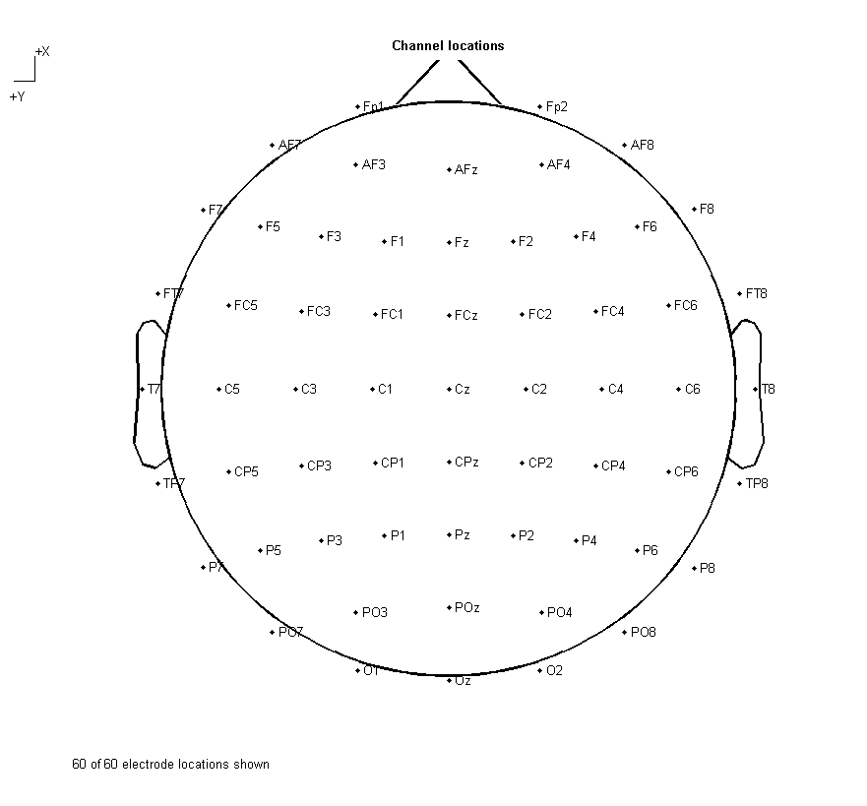
In the script CLASSIFY_SINGLETRIAL_ODDBALL.m
Will probably require EEGLab download (I use v. 12_0_2_1b, but any should do)
http://sccn.ucsd.edu/eeglab/install.html
- Remove bad ICA components
- Downsample to 250 Hz
- Standards and Targets were time-shifted by 452 ms following the trigger (27 frames @ 16.67 ms refresh rate) to account for stimulus presentation delays for these conditions.
- 30 random Standards are selected to equate trial counts for initial trial averaging
- Then to set up classification, the minimum number of trials per condition were matched across subject sessions and matched control (ON, OFF, CTL). So if a subject had only 28 target trials in the ON condition, 28 targets were selected from their OFF condition target condition and their matched CTL target condition.

- Averages across conditions are shown here.

  - The normal thing to do would be average within each subject to increase signal:noise, then average across these individual (random effects) averages to get a grand average for each condition.
  - This approach facilitates statistical comparions across conditions/groups (fixed effects) based on strong SNR for random effects (a mixed model).
  - However, there are too few subjects to classify in this manner so I opted for a purely fixed effects analysis by combining all trial types across subjects without within-subject averaging.
  - Note that this is only 1 electrode (FCz) shown below.
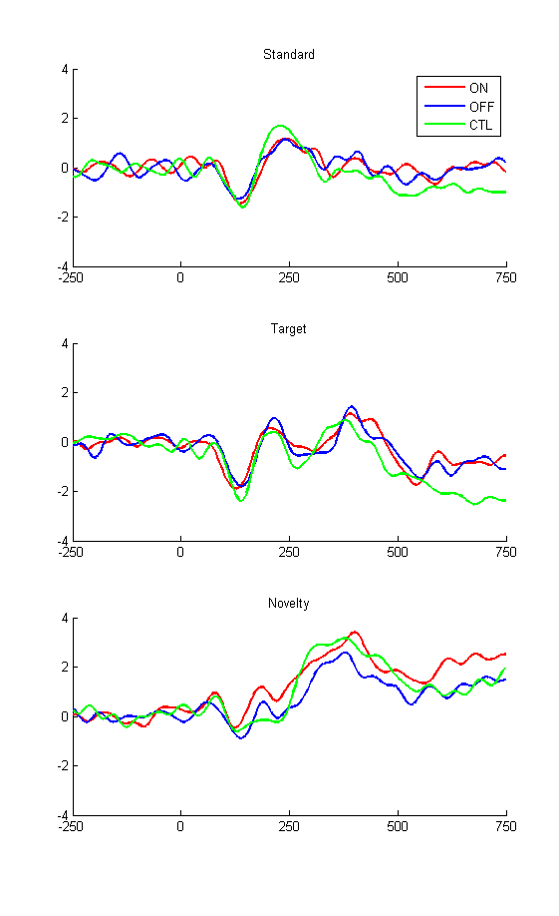
- RUN_CLASSIFY.m
  - Can enter any 2 bivariate conditions
  - Trial count matches the 2 conditions
  - 5X cross validation
  - Spatiotemporal bins of 60 electrodes * 12 samples (48 ms) were used as input
    - Bins were shifted to overlap by 50%
    - From -250 ms to 750 ms peri-tone
    - See Cavanagh & Castellanos, 2015 NeuroImage
  - Lasso.m was used for classification
  - Training set (random 60% of trials)
  - Test set (random 20% of trials)
  - Validation set to select best LASSO weights (random 20% of trials)
  - Discriminating beta weights were saved
    - Oftentimes these are difficult to interpret!
  - Iterated 5 times and averaged (although 50 times is used for publication)
This also DISPLAYS the outputs (i.e. the data saved in N12 Classification Outputs)
See pix folder for some classification outputs

