DreamScar

Game proposal document

Developer: Mark Oates

euph_boy@hotmail.com

2/12/2008

Introduction

Imagine waking up in the middle of a large field, you have no idea where you are or even who you are. Suddenly you see someone coming towards you. As she gets closer, you see that it’s a young woman who asks with urgent desperation, “do you remember!? Do you?”

you don’t recognize her, so you begin to ask her questions:

“… Who are you? Where are we? Who am I?”

she looks troubled, and begins to look away, saying

“This isn’t the right time… this is the wrong place. How could I have gotten it wrong? I had all the clues!?”

She begins to walk off from where she cam from and you ask “Wait! What’s going on here?!”

“I can’t tell you… I’m sorry. You’ll understand why. But I can’t tell you.”

She runs off and disappears into the distance. Leaving you all alone.
Synopsis

DreamScar is a dark, dramatic, and mysterious top-down 2d adventure game where you wake up in the middle of an open field not knowing where, when, or who you are. You are given your first clue by a strange girl who runs towards you frantically asking, “Do you remember? Do you!?”

When she leaves you stranded with more questions than answers, you begin to look around for clues to whom and where you are. But most importantly, you find a cryptic scar on your left arm with what looks like symbols or some strange language which you can’t read.

As you walk around you encounter strange, odd creatures that can hurt you. You collect weapons and items to help get you around to finding new clues to bring you ever closer to solving shit strange mystery.

Eventually, you find a mysterious portal and decide to step through. Once you reach the other side, you find a new scar on your arm, with what looks like a map to a destination.

When you get there, you find the same girl from the empty field, but she is completely lost and confused, has no idea who she is or how she got there. You both begin searching and find another portal, which you pass through together, only to find yourself alone on the other side, with a new scar on your arm.

Each pass through a portal gives you a new clue to the greater mystery you face, giving you new maps, quests, journeys, items.

As you move through the game, you discover more about your relationship with the unknown girl, who shares with you some of your deepest secrets, which you must trade in order to keep one another alive. The story unravels into a wild conspiracy involving scientific experiments on mind control and the persistence of human thought.

Follow the journey of our protagonist as he makes his way through seemingly endless journey. Where are these mysterious scars coming from and who is putting them there? Who is it that is on your side guiding you through? The only way to find out through this bizarre twisted world is to keep on keeping on.
Gameplay:

Gameplay uses a combination of the keyboard and mouse. Player movement is done by using the aarow keys, ASDF configuration, or any other user-defined keys, while the mouse cursor controls the viewing depth and aiming direction for the player.

An adaptation to this method will have to be made if the game is to use the controller. Player movement and target pointing will have to be done with dual joysticks, which would leave action controls to the trigger buttons. This could be potentially cumbersome so the idea and game play may have to be modified slightly to streamline joystick input.

In addition to the player map movement, there will be an inventory screen where the player will be able to choose and use items that you have collected throughout the game. Some items may include:

Basic Items:
Keys
Various foods, drinks (for replenishing health)
Health container (increases the players max health)

Weapons:
knife
Rifle
Laser blaster
Metal pipe
Ammunition
Dynamite

Special Items:
Unique keys for unique doors
Site to site transporter

Armor:
Snow suit
Environmental suit
Early screenshots:
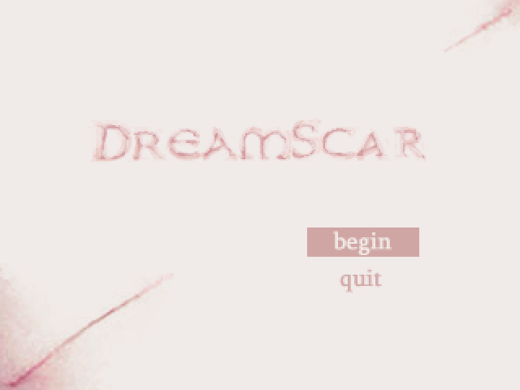
title screen
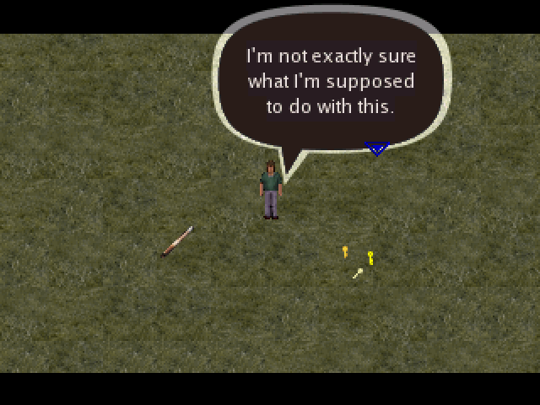
an early screenshot showing scripting events
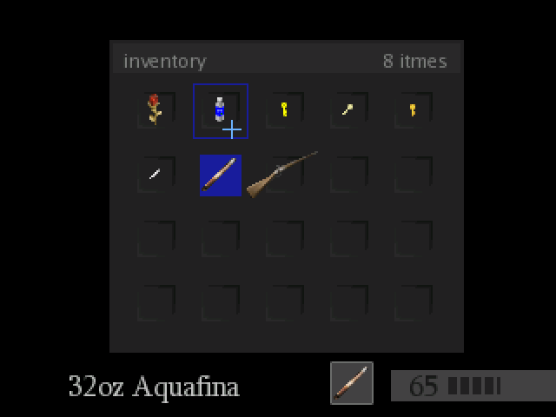
an example of the inventory screen

Point by Point Outline:

2.2 Game is for entertainment purposes only
2.3 The intrigue of the game comes from the story
2.4 Platform – XNA
2.5 Adventure
2.6 Teenagers so adults
2.7 Teen+
2.8 Single player
2.9 The goal is to find out who you are and what happened to make you forget
2.10 Player is the main character, and his job is to discover and solve his disappearance
2.11 thrid person top-down
2.12 There are several settings, to be determined by level and puzzle designers
2.13 Without going into every point in the story, you eventually discover items to get into places and defeat enemies. But to advance the story, you find time/space portals from which you can travel from one place to the other. As you travel from one to the next, scars appear and disappear on your arm, evidence of where you’ve been and what you need to remember in order to find the next portal. You meet a girl between locations, but each time you meet her she is at a different temporal point then you… meaning, sometimes she remembers you, or important clues, has powerful weapons, or sometimes she is at the beginning, not knowing who she is, where she is. There is only one end, where you fully discover where you are and what your purposes are inside this time/space paradox, and how to get out.
2.14 The player must collect clues and items, traverse mazes, defeat basic enemies, and more challenging enemies.
2.15 there are two characters in the game, yourself and the girl.
2.16 The game is structured alternating gameplay and story development. There will be successive levels with minimal amounts of backtracking.

3.1 The player will level up with equipment, which is obtained throughout puzzles in the game
3.2 walk, attack, talk, pickup items, move blocks, use keys
3.3 kill enemies, collect items and equipment, solve the mystery.
3.4 yes, the player’s inventory will be on a separate screen, though a hud will display the the currently selected item.
3.5 the player will move between different dimensional areas, which can provide for a wide variety of game play ideas. For the most part, time will change throughout the game as the player discovers new portals and dimentions. You could wind up anywhere!
3.6 The level/life system will be similar to the legend of Zelda. The player will be able to continue at various beginning points throughout the game, and will be able to increase his health meter with special items.
3.7.1 keyboard or controller (preferred)
3.7.2 You will obtain clues and they will mysteriously appear as a scar on your arm. Your scars will act as a map, or decipher for some clues you would otherwise forget if you passed through a portal.
3.7.3 player moves by walking around the map
3.7.4 A hud will provide info on various status (life meter, ammo, etc)
3.8 The player will progress through the story in a semi-linear fasion (even though the events will take place in a non-linear way within the context of the story)

Audio and Video
4.1.1 2D top-down with hand-drawn semi-realistic characters
4.1.2 The game will be very dark and desaturated, drab and erie, very dirty settings and strange creatures
4.2.x Basic erie music and sound effects. There might be room for voice over, though I would like to keep the size of the game to a minimum to increase downloads.
4.3 There will be various special game-play/environmental elements throughout the game, including snow, rain, fire, etc… which will affect gameplay.

